Course Project Documentation

CS101 Project

TEAM :245

**Stickman**

**1) Mehul Khandelwal- 140110097**

**2) Shravan Tangudu- 140010027**

**3) Gopal Kedia- 140010057**

**4) Aditya Krishnakumar- 140010004**

**INSTRUCTOR: KAVI ARYA**

Table Of Contents

1. Introduction..................................................................................3 2. Problem Statement......................................................................4 3. Requirements...............................................................................5 4. Implementation.............................................................................6 5. Testing Strategy and Data............................................................7 6. Discussion of System..................................................................13 7. Future Work.................................................................................15 8. Conclusion...................................................................................16 9. References...................................................................................17

1. Introduction:

This document provides a detailed description of our software viz.

STICKMAN.

It provides description of the different types of requirement of the

software system. It will also brief the technical aspects of the

software such as the purpose and features of the system, interfaces

of the system, what the system will do.

1. Problem Statement:

To make a stick figure which can perform basic functions like walking, kicking, running ,jumping .

To render the images and the figure according to the need of the layers.

To add other features like a crack , a burn spot etc. synchronized with audio effects.

To enclose all of this in an interactive game.

We are using SDL Library incorporated with C++ in Code Blocks.

3. Requirements:

1. Hardware Requirements:

* Computer with 256 MB RAM
* Speakers
* Mouse
* Keyboard

B) Software Requirements

This software is basically supported on any interface whether it is

MS Windows or LINUX Ubuntu.

1. Implementation:

We created sprite sheets that will be used for the animation.

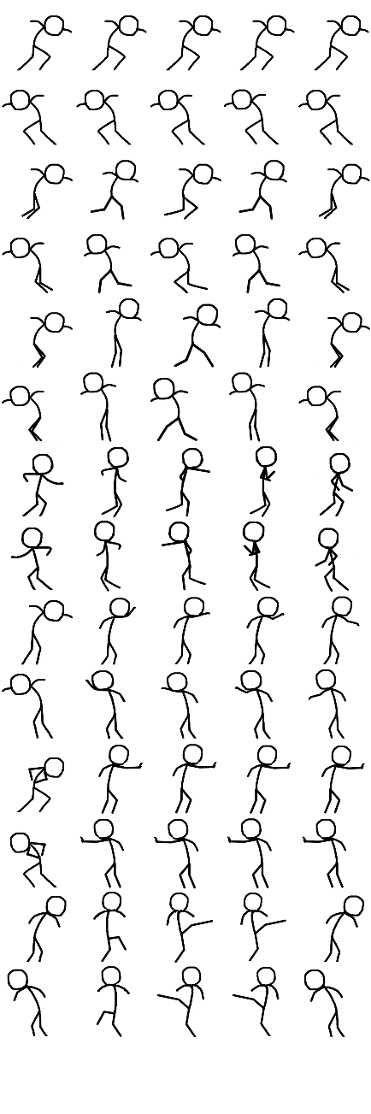

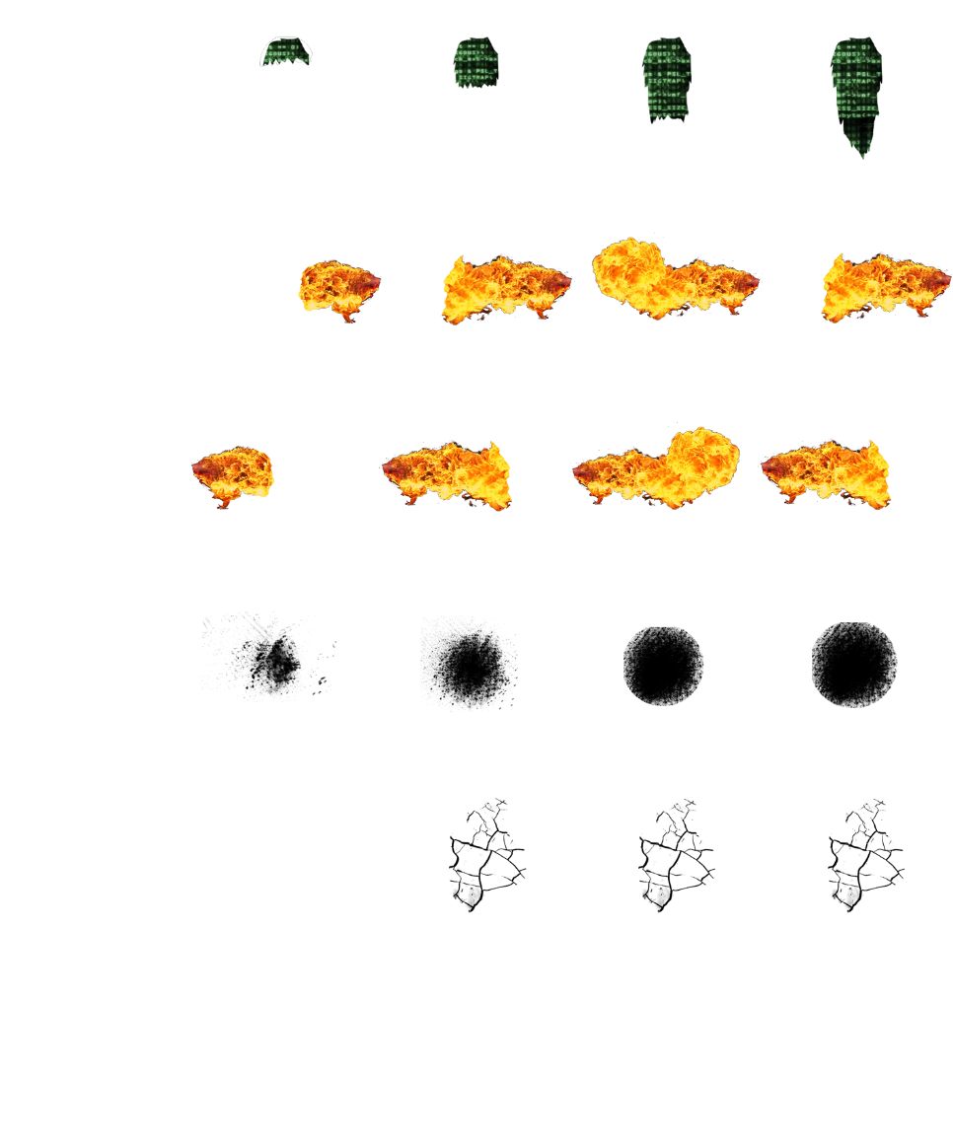

The animations used consist of multiple frames which will be displayed one after the other whenever the required function is called.

A Help template, or User Manual regarding the issue on how to use the software, the basic software requirements, and the constraints and assumptions made during the development of the project will be displayed to the user.

**Weekly division of work –**

February (22nd – 28th) – From 22nd to 28th of this month we decided to model the outline of our stickman code and distribute the work equally among the team members.

March (1st -15th) - In this period, we will complete the functions regarding interface, display, and find a graphics package for image synchronisation.

March (16th -31st) – Start making the frames and write the code for different actions to be performed by the figure .

April (1st- 14th ) – Using vector function for adding effects and assigning appropriate sound for every defined action.

1. Testing Strategy and Data:
   1. **Test data**

Since the animation used is frame wise, the movements or the actions may appear to be broken and shabby. This can be fixed by using lot of frames. There will be specific functions for every action of the stick figure due to which the program’s response may not be spontaneous. The code can be made more efficient to tackle this problem. We will attempt to make different combinations of the performed actions. We will also put sound effects for the actions performed. VECTORS will be used for image processing.

* 1. **Test Cases**
* **PLANNED SCENARIO**

The program should run smoothly. The stick figure should be able to walk, run, punch, kick, jump and burn things on the screen. Also the sound effects and the image processing should be in synchronization with the action.

* **ACTUAL SCENARIO**

The stick figure is moving properly and is also able to perform the promised functions. But it is not that smooth because SDL does not promise such great animation. The image rendering for movements is quite good .We have used vectors for that purpose. Overall, it is as good as we expected using SDL.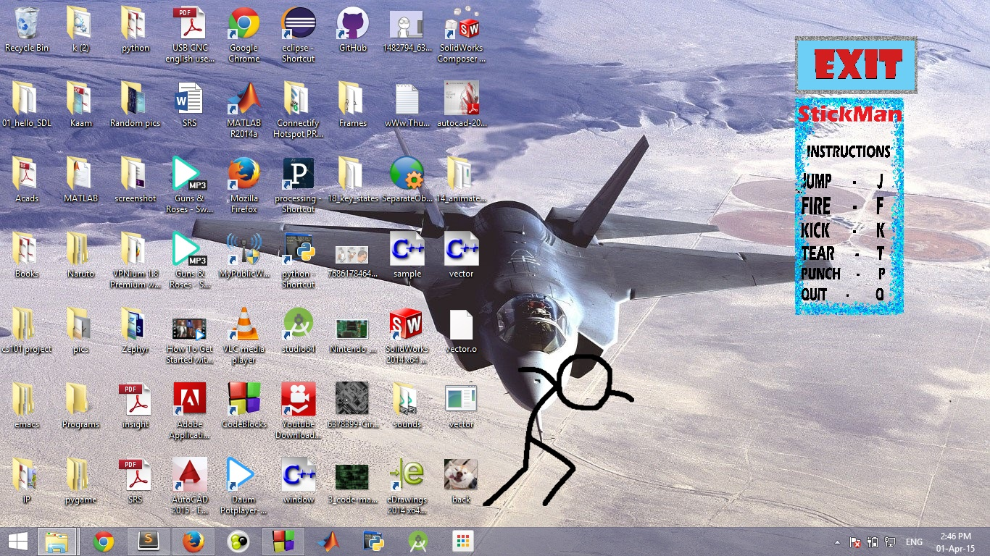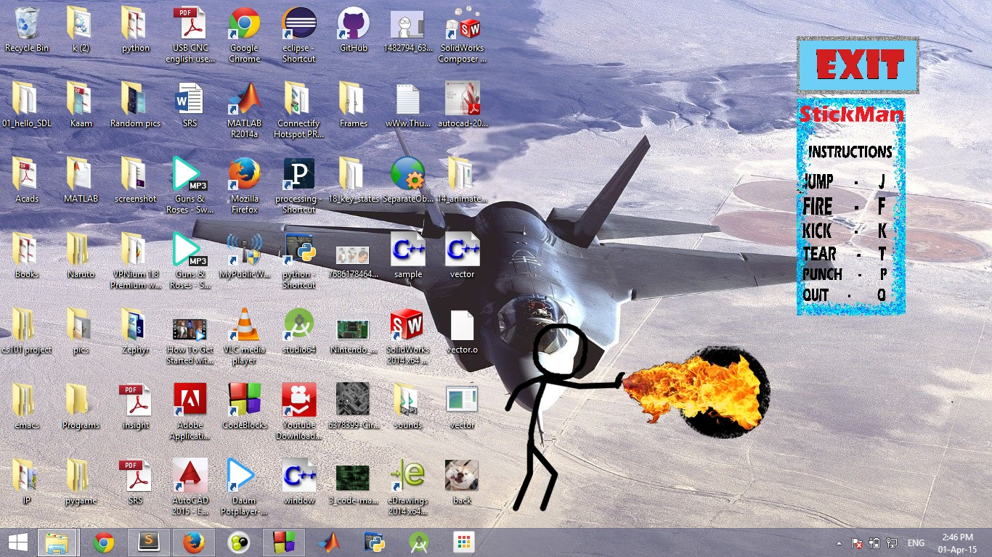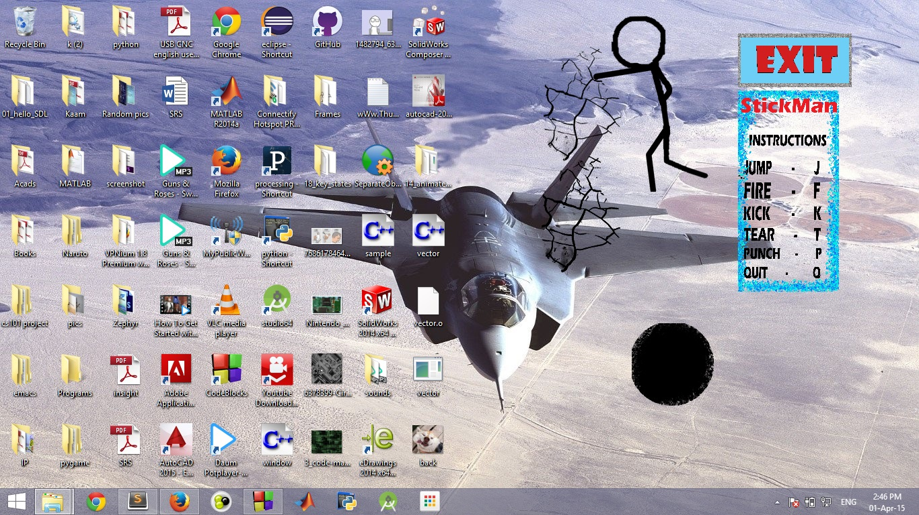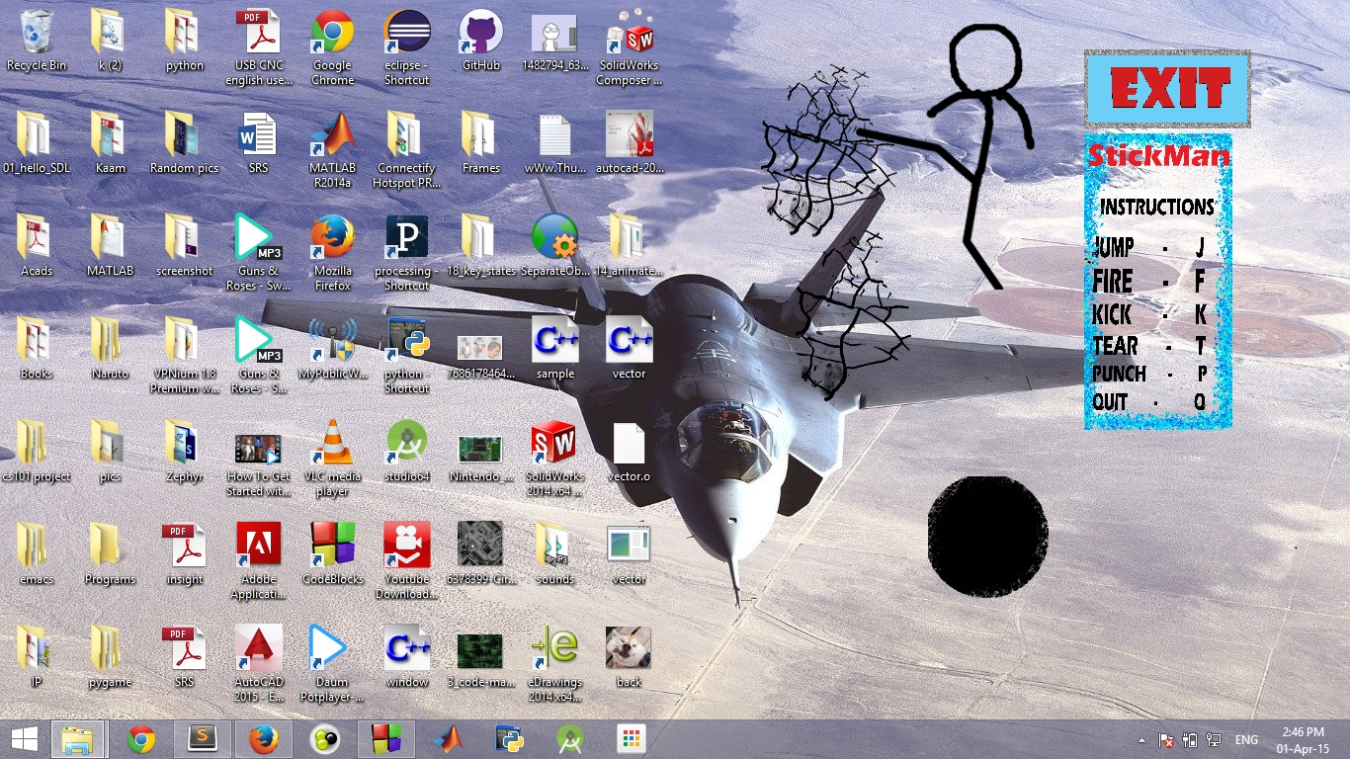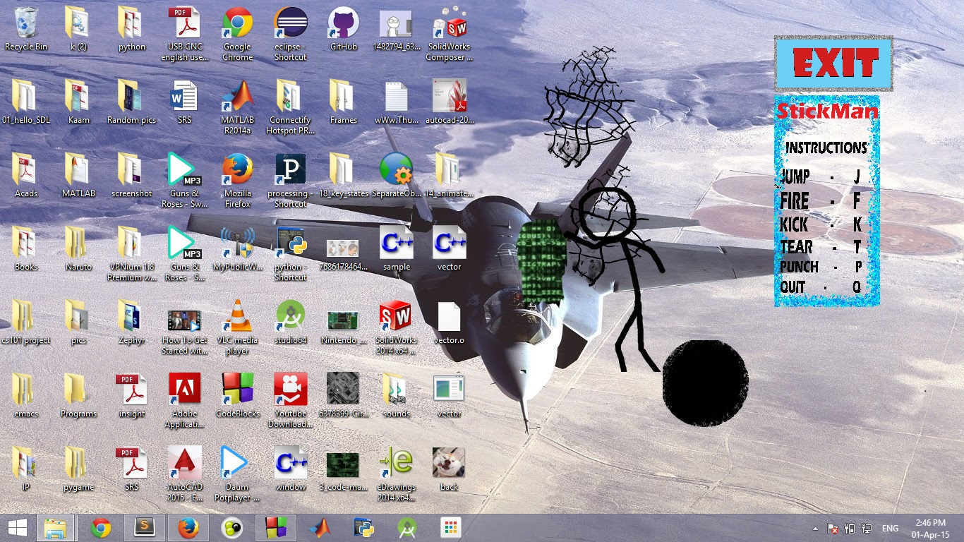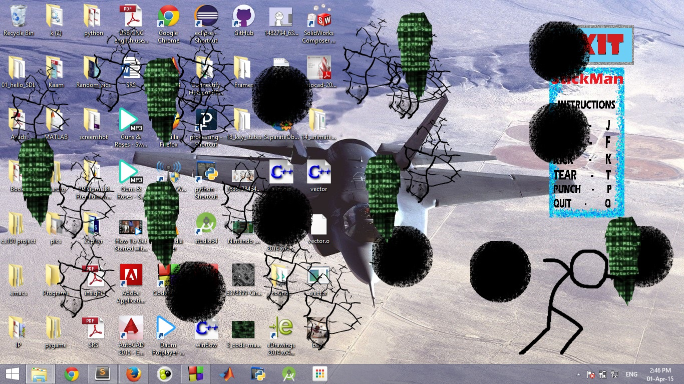

* **Testing Methods –**

**Easy –** The easy part of the code was to render images, using keys for different functions in the program, and making the sprites for different actions to be performed.

**Moderate –** The functions regarding various actions of the figure, toggling between various frames for a particular action and using the mouse cursor for exit button.

**Tough –** The difficult portion lies in the part where sound has to be synchronized with its movements and creating the effects related to the movement performed by the stick figure.

* 1. **DIVISION OF WORK**

The project is almost equally divided amongst the four group members as follows-

**Mehul Khandelwal -** will write the function for all the actions and movements of the figure. He will also make the exit button executable with the mouse.

**Shravan Tangudu -** will do coding for basic appearance of various layers. Will code and make sprites for all frames. He will also write the outline of the code.

**Gopal Kedia -** will do coding for image synchronization with the action performed by the figure using vectors. He will also work for improving the program so as to minimize the lag.

**Aditya Krishnakumar -** will add sounds effects and coordinate their timing with the action.

1. Discussion of System:
2. What are worked as per plan?

As mentioned in the SRS we were able to complete all the action performed by the stickman. We added sounds and appropriate effects also.

We tried our best to synchronise the sound and the actions.

1. What we added more than discussed in SRS?

We added an exit button, start button, some extra features of the stickman’s movement and an exit animation for the stickman.

(C) Changes made in plan:

Instead of using a separate image for every action we combined all these images into a sprite sheet that will be used according to the need of the functions.

1. Future Work:

This project after some upgrades in graphics and performance can be used in games in which the user will have the liberty to perform various functions. We can also add more characters that can interact amongst themselves and have more features.

1. Conclusion:

We tried to make an interactive interface that helps the user play around with his desktop.

We created a program which is quite different from the usual kind of games that one may find.

We used the concepts of vectors in C++ that is new to us.

This project also gives an idea as to how one can do animation using C++.

1. References:

<http://en.wikipedia.org>

<http://www.google.co.in/>

<http://stackoverflow.com/>

<http://lazyfoo.net/tutorials/SDL>